###### **A**

**PROJECT REPORT**

## **ON**

**Website for**

**“Multinational Companies”**

**SUBMITTED TO**

**SHIVAJI UNIVERSITY, KOLHAPUR.**

For the partial fulfillment of the certificate of

**Bachelor of Computer Applications (Sem -IV)**

**By**

**1. Miss. Pooja Bhagawan Munde.**

**2. Miss. Tejasvini Bharat Chavan.**

**3. Miss. Gita Mahendran Mudliyar.**

**4. Miss. Farajana Shakil Dundage.**

**UNDER GUIDANCE OF**

**Mr. Chougule S. A.**

**(M.C.A)**

**THROUGH**



**PRINCIPAL**

**MIRAJ MAHAVIDYALAYA, MIRAJ**

**2016-17**

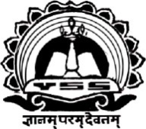

**Miraj Mahavidyalaya, Miraj**

**CERTIFICATE**

*This is to certify that the project entitled* ***“***[***Web site For***](http://www.facebook.com/Sunny1008) **Multinational Companies”**

*submitted by*

**1. Miss. Pooja Bhagawan Munde.**

**2. Miss. Tejasvini Bharat Chavan.**

**3. Miss. Gita Mahendran Mudliyar.**

**4. Miss. Farajana Shakil Dundage.**

*in practical fulfillment of the requirement of the award of degree* ***Bachelor of Computer Applications (B.C.A.) Part II (Sem-*IV*)*** *to* ***Shivaji University, Kolhapur*** *has been carried out by him under my guidance satisfactorily completed during the academic year 2016-2017.*

*To the best of our knowledge and brief the matter presented by them is original in nature and has not been copied from any source. Also, this report has not been submitted earlier for any degree or diploma of Shivaji University or any other university.*

**Mr. V. T. Patil Dr. C.T. Karande**

*Head of Department Principal*

**Examiner 1: -** . . . . . . . . . . . . . . . . .

**Examiner 2: -** . . . . . . . . . . . . . . . . .

*Place: Miraj*

*Date :*

**GUIDANCE CERTIFICATE**

This is to certify that the project entitled

**Website for**

**“Multinational Companies”**

Conducted for **Miraj Mahavidyalaya, Miraj** by

**1. Miss.Pooja Bhagawan Munde.**

**2. Miss.Tejasvini Bharat Chavan.**

**3. Miss.Gita Mahendran Mudliyar.**

**4. Miss.Farjana Shakil Dundage.**

in fulfillment for the award of Bachelor of Computer Applications-II(Sem.IV) submitted to Shivaji University, Kolhapur has been completed under my supervision and guidance.

To the best of our knowledge and brief the matter presented by them is original in nature and has not been copied from any source. Also, this report has not been submitted earlier for any degree or diploma of Shivaji University or any other university.

**Mr. Chougule S. A.**

**(M.C.A)**

### Date:

Place: **Miraj.**

Declaration

**To,**

**The Principal,**

**Miraj Mahavidyalaya, Miraj**

**Respected Sir,**

We undersigned hereby declare that the project entitled

”**Website for Multinational Companies** “developed under the guidance of **Mr. Chougule S. A.** is our original work.

The reports generated in the project work are based on the information collected by us.

We have not copied from any other project report submitted to Shivaji University, Kolhapur earlier.

**1. Miss.Pooja Bhagawan Munde.**

**2. Miss.Tejasvini Bharat Chavan.**

**3. Miss.Gita Mahendran Mudliyar.**

**4. Miss.Farajana Shakil Dundage.**

**Date :**

**Place : Miraj.**

Acknowledgement

We express our sincere thanks to our project guide **Prof. Mr. Chougule S. A.** who guided us during the entire session of the project. His evaluations and suggestions have helped us enormously towards the completion of this project.

Also we wish to express our sincere thanks to the **Dr.Karande.C.T.**(Principal, Miraj Mahavidyalaya,Miraj),Mr. Patil V. T.(Head, Department of Computer) for their extraordinary help throughout period of our project. We are also thankful to Teaching & non-teaching staff of computer department and friends for providing us great ideas in making this project.

**1. Miss.Pooja Bhagawan Munde.**

**2. Miss.Tejasvini Bharat Chavan.**

**3. Miss.Gita Mahendran Mudliyar.**

**4. Miss.Farajana Shakil Dundage.**

C O N T E N T

|  |  |  |  |
| --- | --- | --- | --- |
| **Sr.No** |  | **Title** | **Page No** |
| **1** | **Introduction**…………………………………. | | **1** |
|  |  | Introduction to System………………….. | 1 |
|  |  | Motivation for Web Designing…………. | 2 |
| **2** | **System Requirement Specification**………… | |  |
|  | 2.1 | Hardware requirment…………………… | 3 |
|  | 2.2 | Software Requirements………………… | 3 |
|  | 2.3 | Introduction to HTML………………….. | 4 |
| **3** | **System Design**………………………………. | |  |
|  | 3.1 | Site Map………………………………… | **7** |
| **4.** | **Implimentation**……………………………… | |  |
|  | 4.1 | Output Design…………………………... | **8** |
|  | 4.2 | Coading…………………………………. | **18** |
| **5** | **User Mannual**……………………………….. | | **36** |
| **6** | **Conclusion**…………………………………… | | **37** |
| **7** | **Bibliography**…………………………………. | | **38** |

**Introduction**

**1. INTRODUCTION**

* 1. **Introduction of Project:-**

In the present day world of Globalization, Multinational Companies have played an important role in the development of home countries where the MNCs are operating.

Multinational Corporations (MNCs) or Transnational Corporation (TNC), or Multinational Enterprise (MNE) is a business unit which operates simultaneously in different countries of the world. In some cases the manufacturing unit may be in one country, while the marketing and investment may be in other country.

Foreign direct investment by multinational companies involves much more than just transfer of capital as it brings with them technologies of production, managerial services and other business practices. Employment opportunities created by the MNCs have solved an important problem of unemployment which is an important characteristic of the underdeveloped as well as developing countries.

With the shortage of savings for financing developmental projects, there is need to depend on foreign capital. Inviting and making ways for MNCs to operate in India will enhance the economic development of the country. Prime Minister Narendra Modi’s initiatives for ‘Make in India’ and ‘Skill India’ campaigns, inviting Global Companies to invest in India as well as efforts to simplify the Foreign Direct Investments regulations will certainly make India a favourite destination of MNCs.

**1.2Motivation for Website designing:-**

Internet is a mode through which any information can be accessed in fraction of seconds. The information required by a person is readily available on the site and can be accessed very quickly.

**Web designing is concerned with several factors:**

You should have information according to the users need.

Same user may want to have different information at different time.

If you are designing a web site for a particular thing only then you have to be very careful that all the information related that should be included.

Another important factor is that if the user is not satisfied with the information provided by you; provide some other resources of related information.

The best advantage of a website is that it provides online information to anyone in the world at any time. It makes the user’s job simple to see seven wonders and access the related information with some few clicks.

So we got an idea after browsing many websites of wonders on the internet and we found that there was no any separate web site designed which would show the wonders and their location which would help the visitors to see the seven wonders through the internet whenever they may be.

**System Requirement Specification**

**2. SYSTEM REQUIREMENTS SPECIFICATION**

**2.1 Hardware Requirements:-**

Processor : Pentium 4 and above.

RAM : 1 GB and above.

Hard Disk Space : 160 GB and above.

Printer : Dot matrix/Inkjet.

Monitor : Color or monochrome.

**2.2 Software Requirements:-**

Operating System : Windows XP.

Browser : Mozilla Firefox

**2.3 Introduction to HTML**

HTML stands for Hypertext Markup Language. Hypertext is ordinary text that has been dressed up with extra features such as formatting images, multimedia and links to other documents.

Markup is the process of talking ordinary text and adding extra symbols such as editor’s proof reading symbols are type of markup .Each of the Symbols used for markup in HTML is command that the browser how to display the text.

HTML is computer language, related to computer programming languages like BASIC, C and Pascal HTML has its own syntax and rules for communication markup languages are special type of computer languages they are concerned with only parts of documents according to their functions .They indicate which part of document is title which is subheading which is author name and so on HTML is not really a programming language, but it is a markup language.

HTML is the language of Internet. By using this language you can create a website. It has all the basic word processing program and capable of handling graphics too. If you member that the earlier class it was taught that there are language which need to be compiled or assembled. In this case nothing of that sort has to be done. Just type, save and run.

In most cases you would be using the plain ASCII text file. Then using the HTML language tags you would be able to generate the required shapes or text. But, please remember that since these languages would have their ultimate test in a browser, make sure that the browser accepts that particular tag some tags are not accepted by internet explorer, Mozilla Firefox and some of them are not accepted by Netscape navigator. So make sure beforehand.

**HTML BROWSERS**

As said above a browser is used to create web document it is important

That your computer has more than one browser in it. It is important since it lets you view the document through more than one browser.it gives your document more versatility and makes you sure that your document would run all the browsers .

The two most popular browsers are Netscape communicator (used tube called navigator) and Microsoft internet explorer. Both are quite popular and can be both used in your computer.

**2.4 HTML FEATURE**

The internet is international network of computer that exchange information with each other the world wide web (www) is a vast inter connected library of information art and commerce .The web consists of several web pages.HTML is used to build web pages .Once web is build it can be published on internet Publishing means transferring web page to a server so that people all over the world will be able to read it there is a huge variety of web page for e.g. We have personal home pages business home pages.

Directories (List of web page), search engines & artists projects .Once the world page is published, it can be accessed through internet explorer or Netscape navigator are web browsers .HTML can be used to build any type of web pages .It is a universal language for classifying the function of different parts of your page .You can indicate which part is title

Which part is addressing which part should be emphasized and which part should include an image so on.

HTML specifies parts of your document so that a browser can display it correctly. This is allow the document to be displayed on many different kinds performs. That is a document can be displayed on different hardware having different operating systems.

**2.5 Advantages of HTML**

1. for creating HTML document what you need is only text editor no special software is required .ex:-In windows you can use notepad for typing a HTML document.

2. You will have much better concept of the structure your page and understanding of it works.

3. If something is no working, then fining error is easy in HTML.

4. Learning HTML is similar than any other programming language.

5. You can work independently and need no to worry about your editing programs.

6. HTML will not cost you anything for its use there are no expansive licenses to buy or no upgrade to purchase.

The different tags that are used in the Project.

Text formatting tags:-

<B>…</B>, <h1>…</h1>, <hr>, <font>…</font>, etc

**2.6 Limitation of HTML**

1. Any simple calculation cannot be done HTML.

2. It cannot be used to display even a date.

3. The interactive web page cannot be built in HTML.

4. Any hyperlink is provided in HTML but for that we need a trip to server

At each step.

5. The web pages developed in HTML do not have their own interface.

**Design**

**3 DESIGN**

**Implementation**

**4.1 OUTPUT DESIGN**

**Homepage**

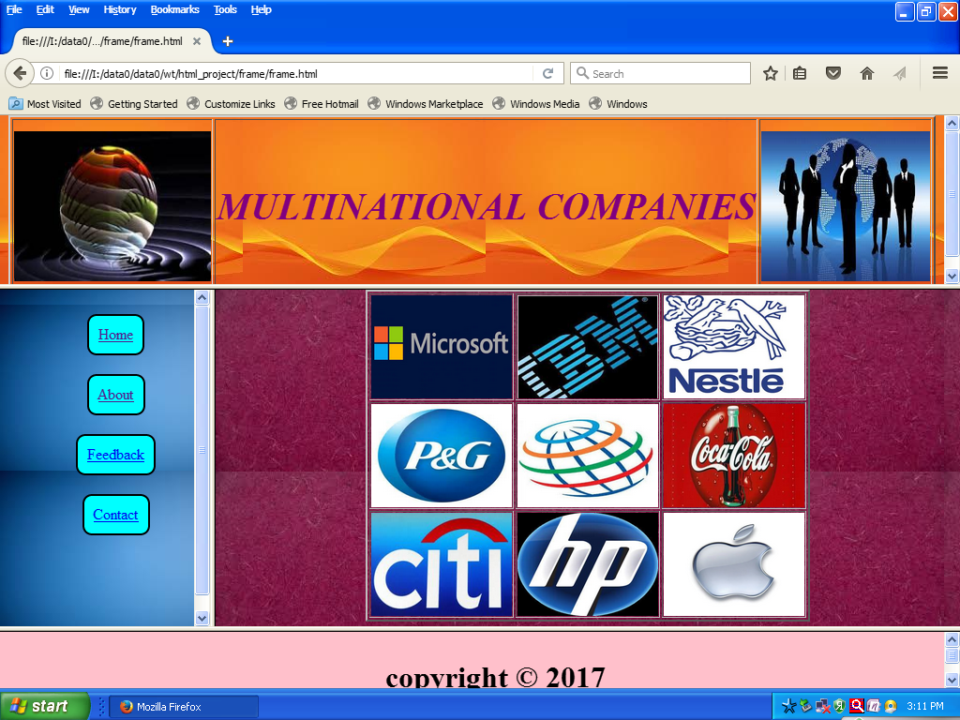

**About Us**

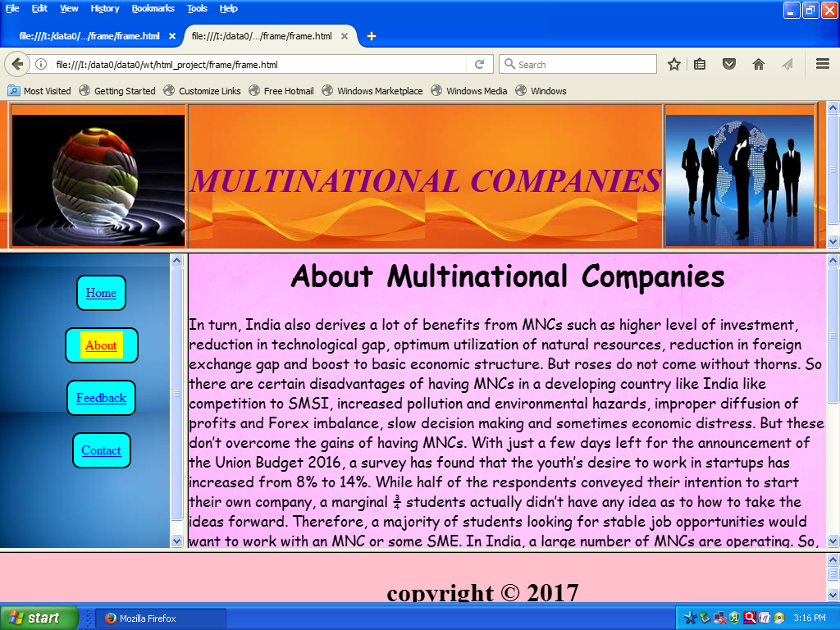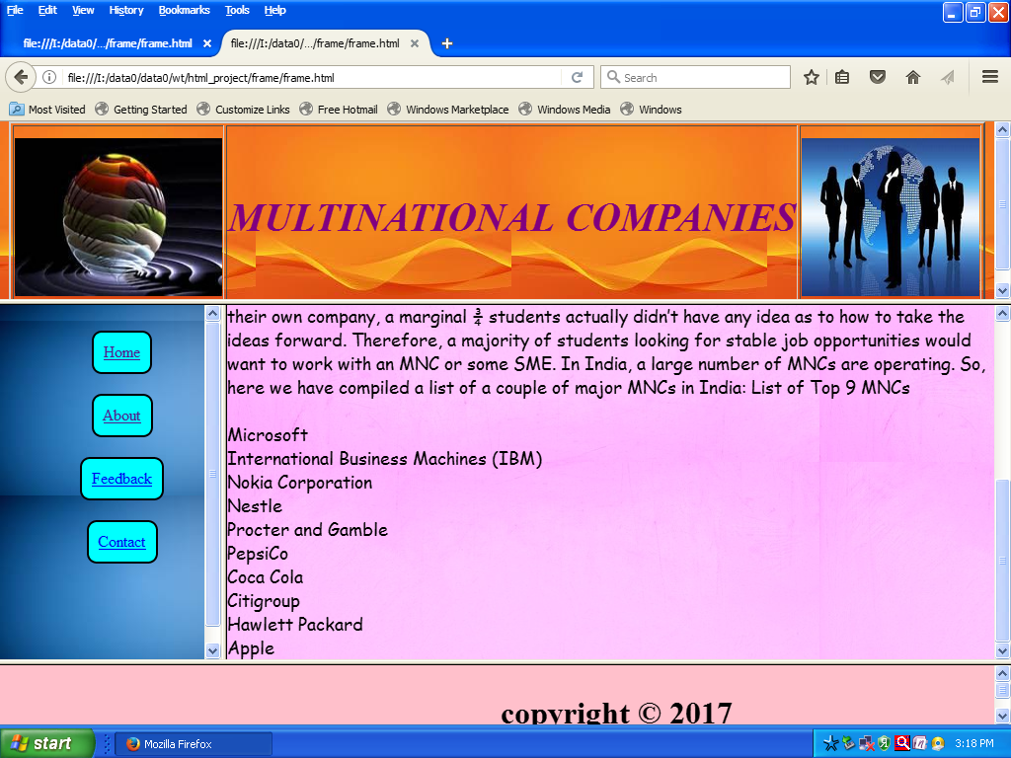

**Feedback Form**

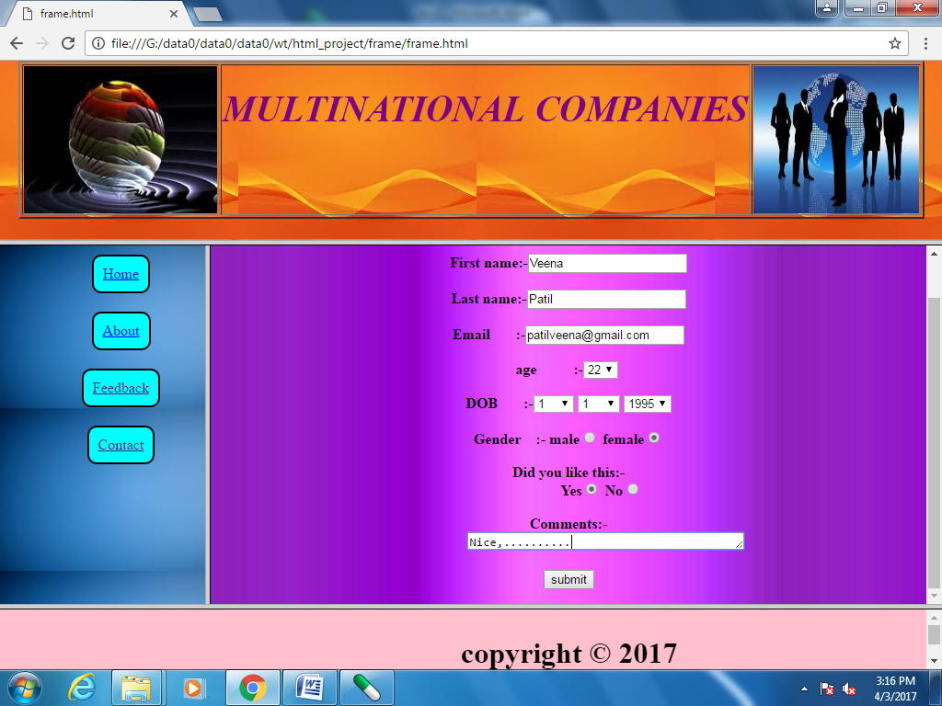

**Contact Us**

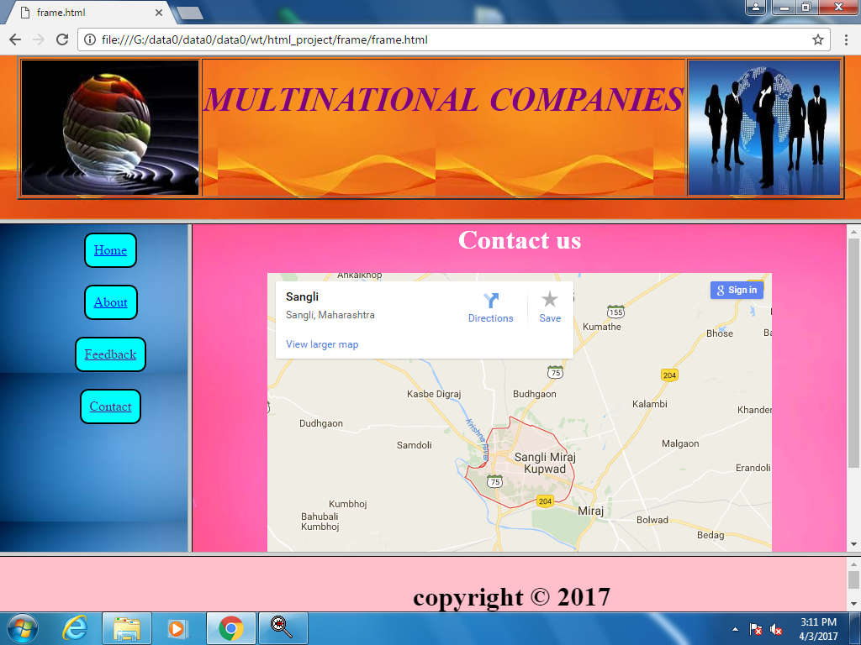

**Microsoft**

**Introduction**

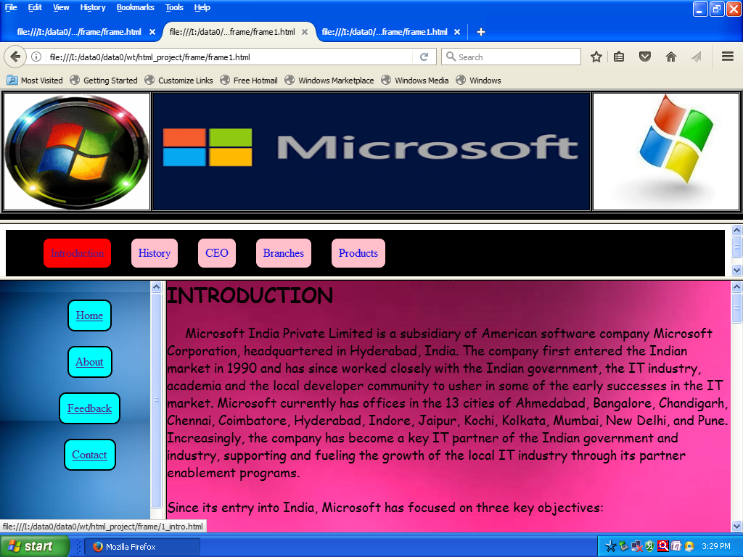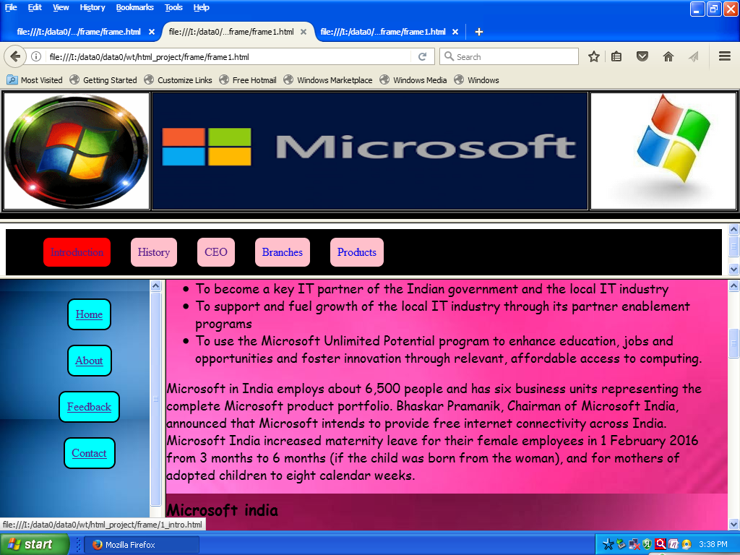

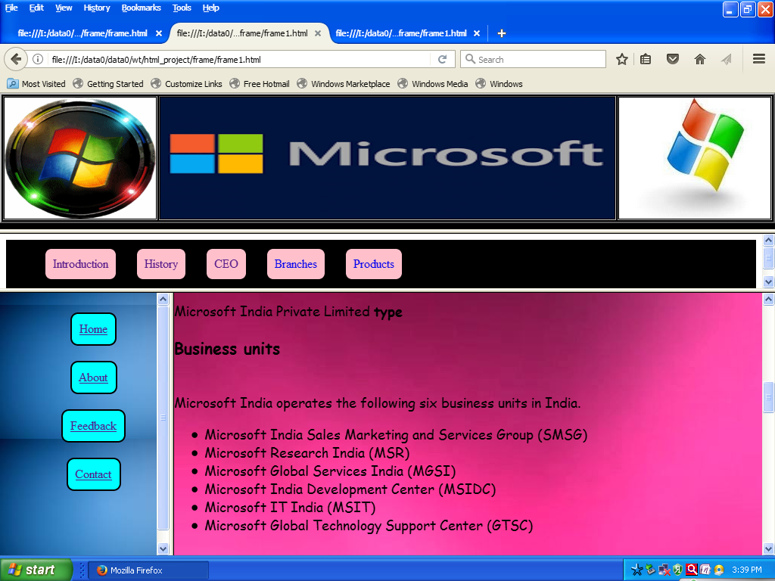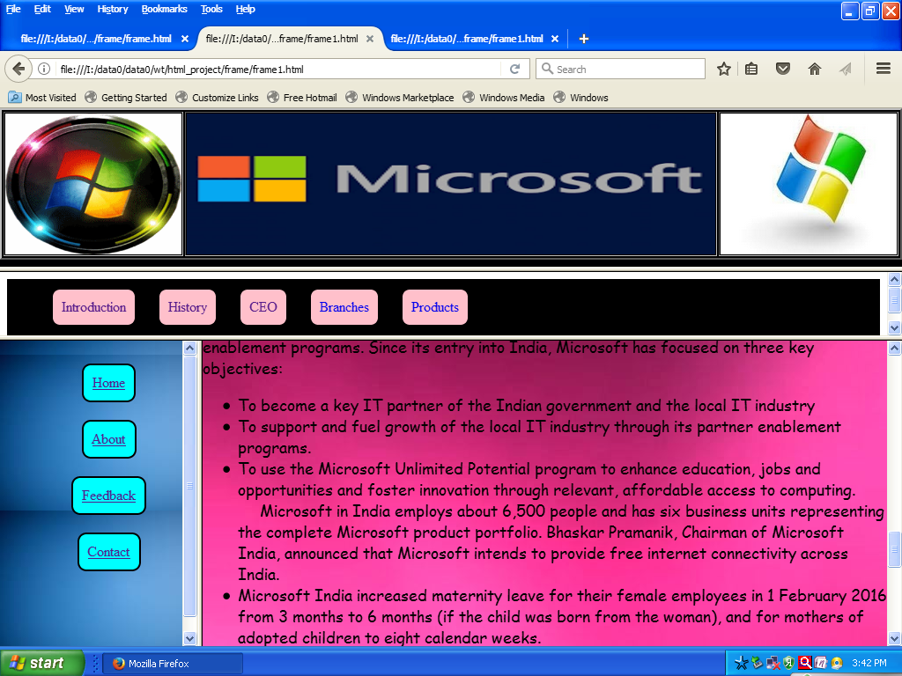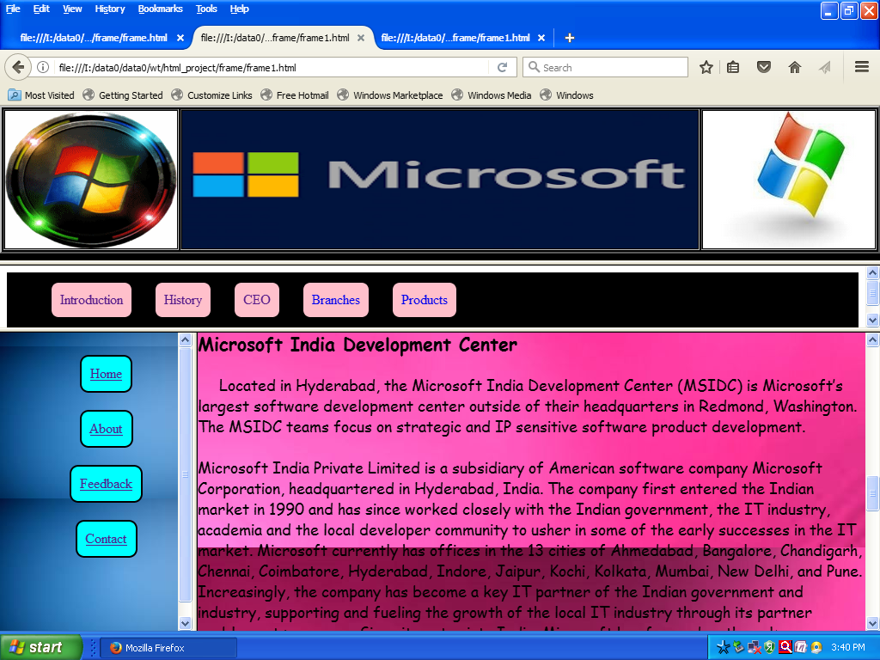

**History** 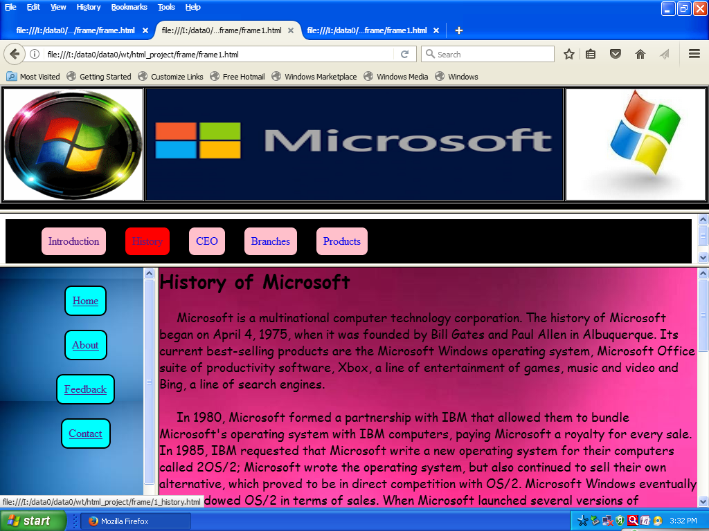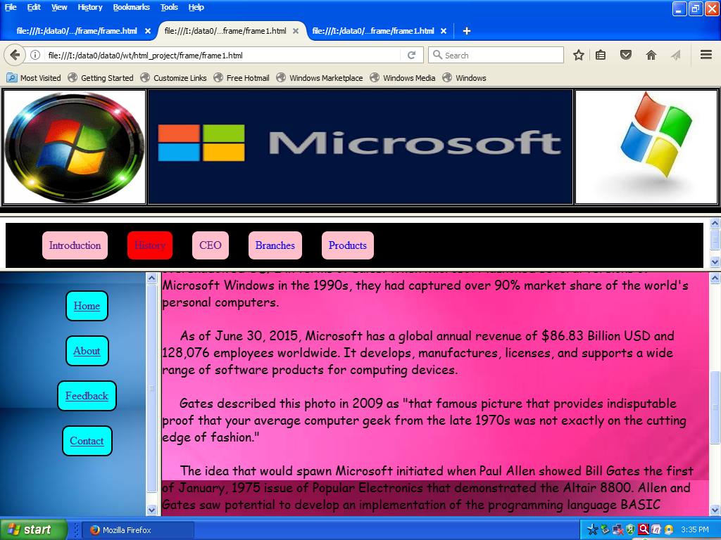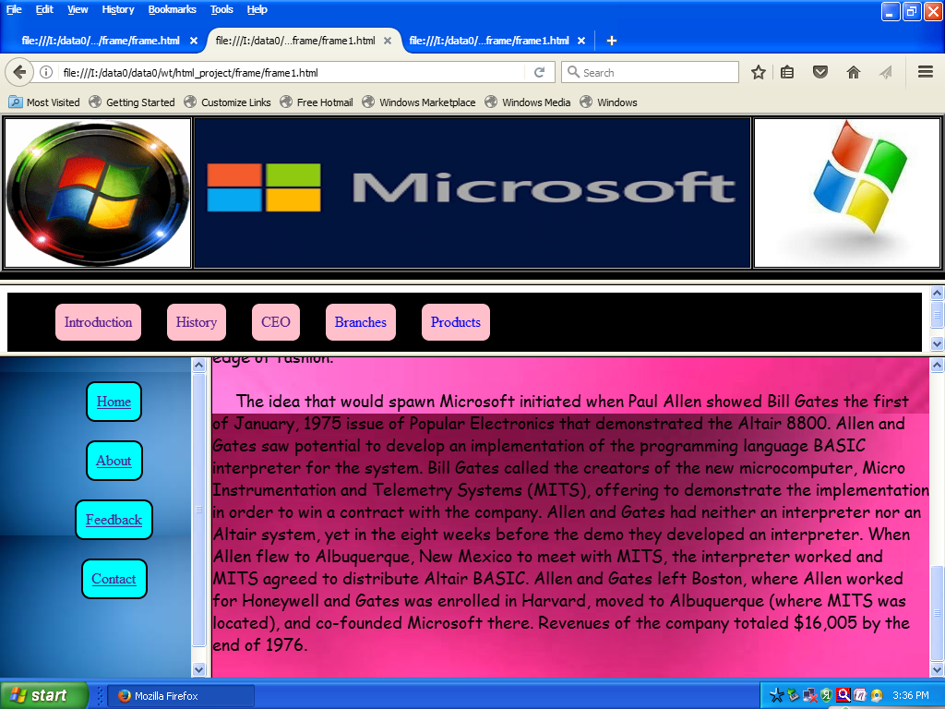

**CEO** 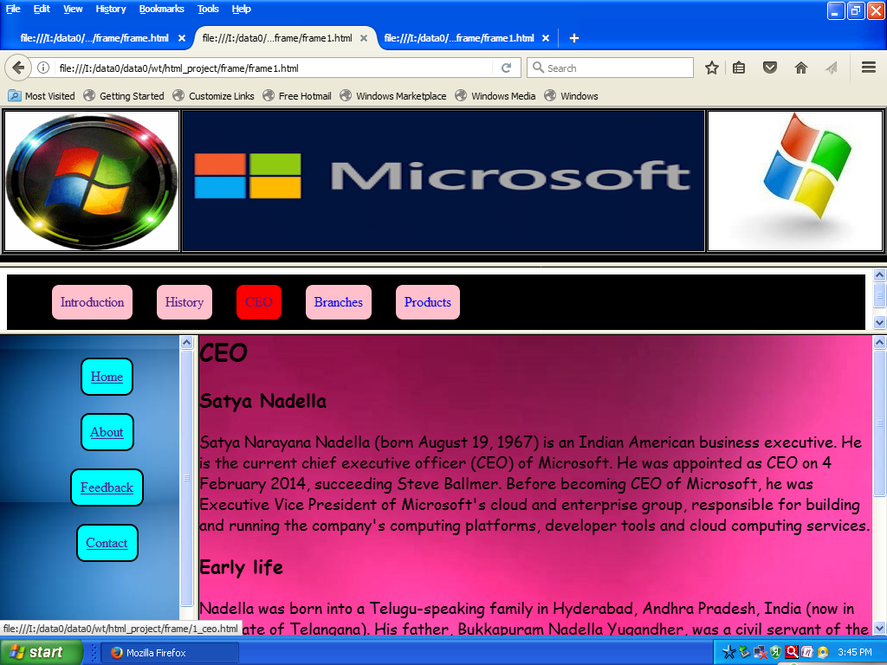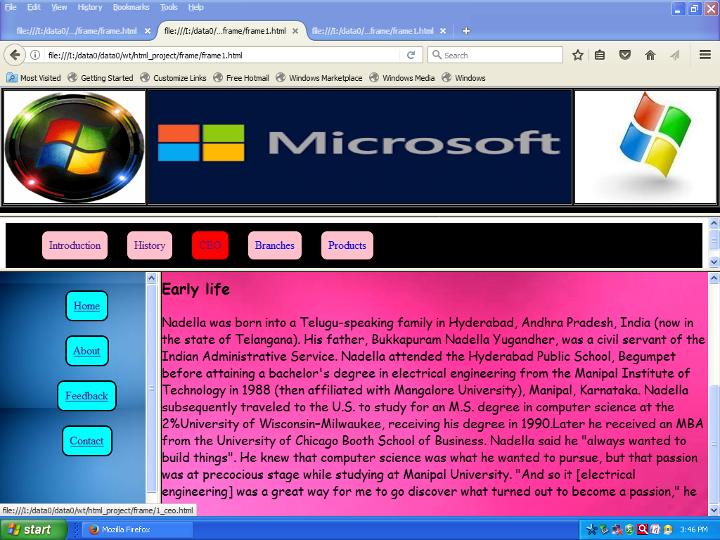

**Branches**

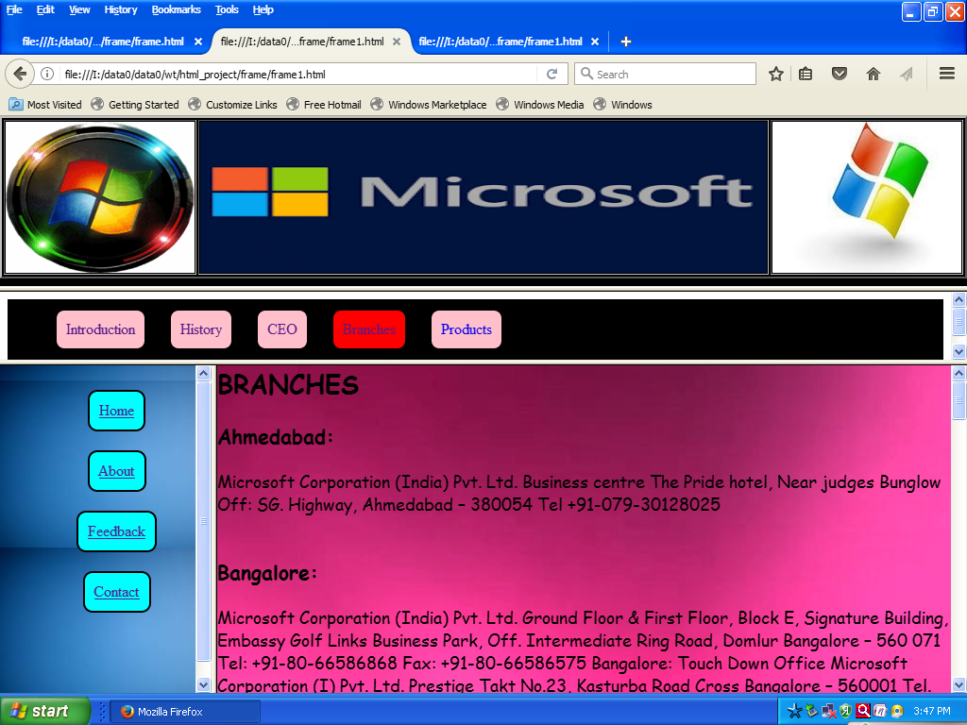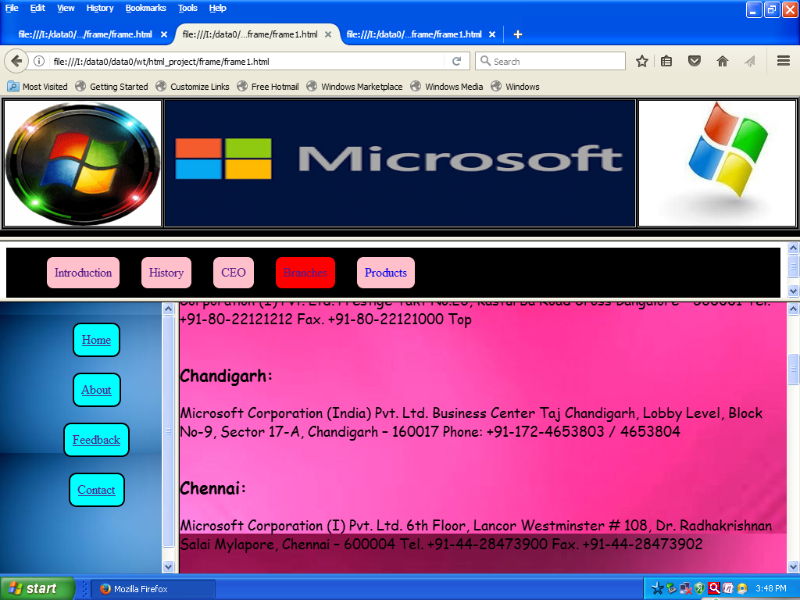 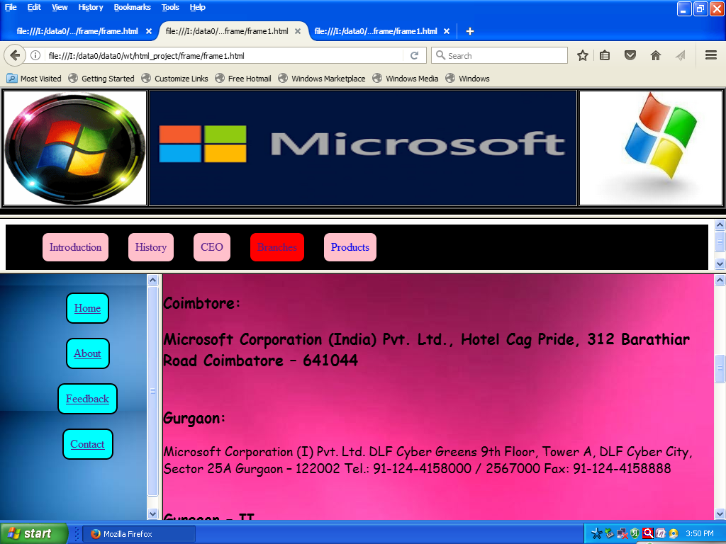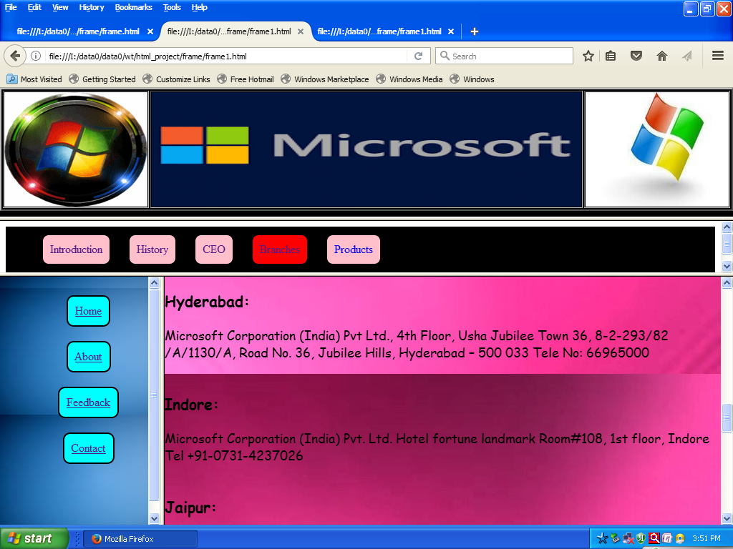 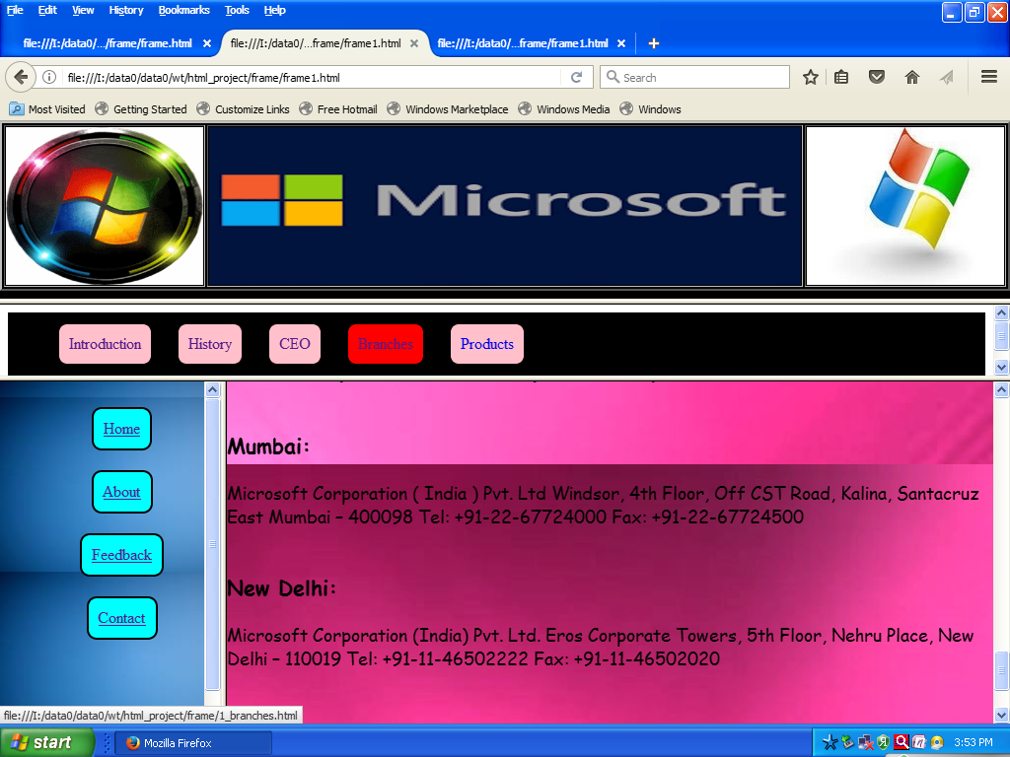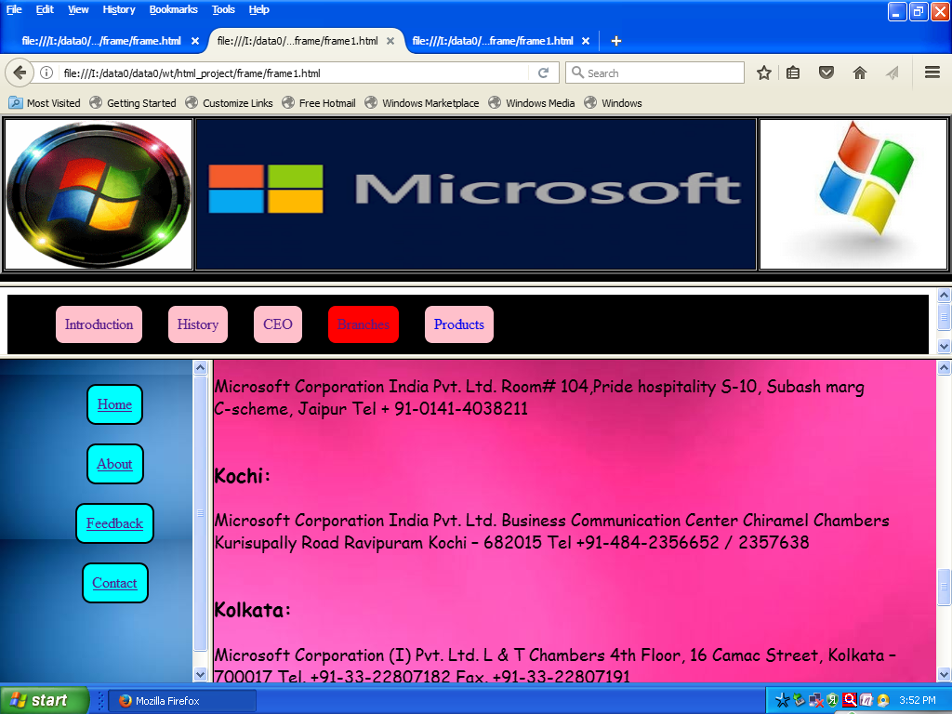

**Products**

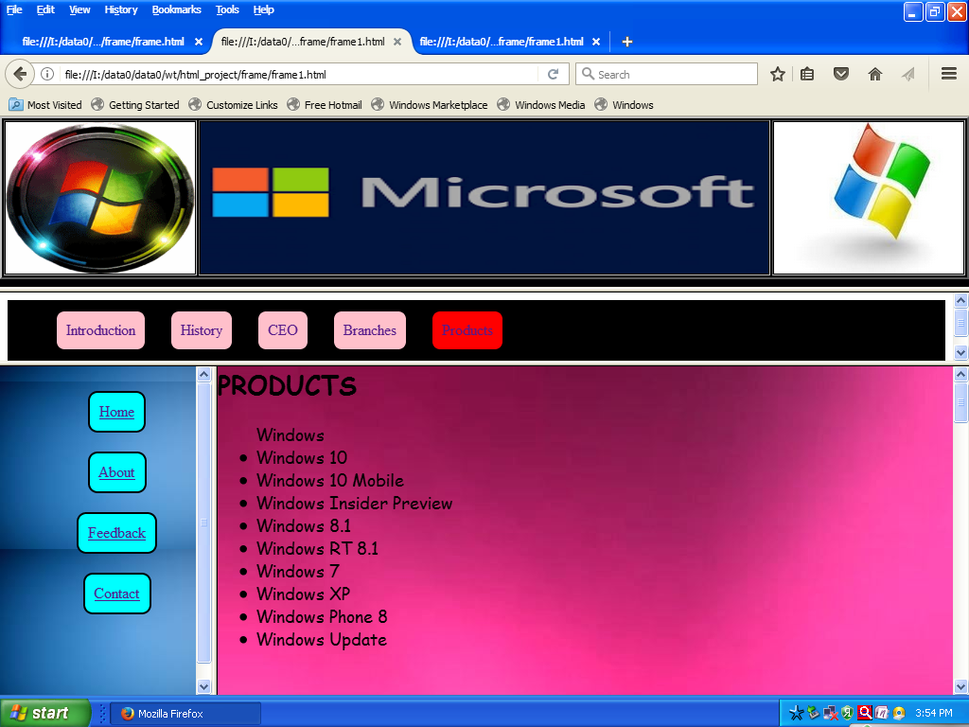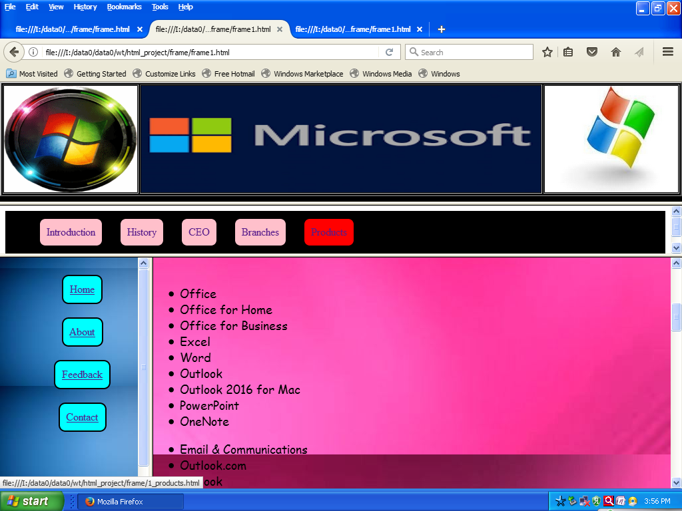

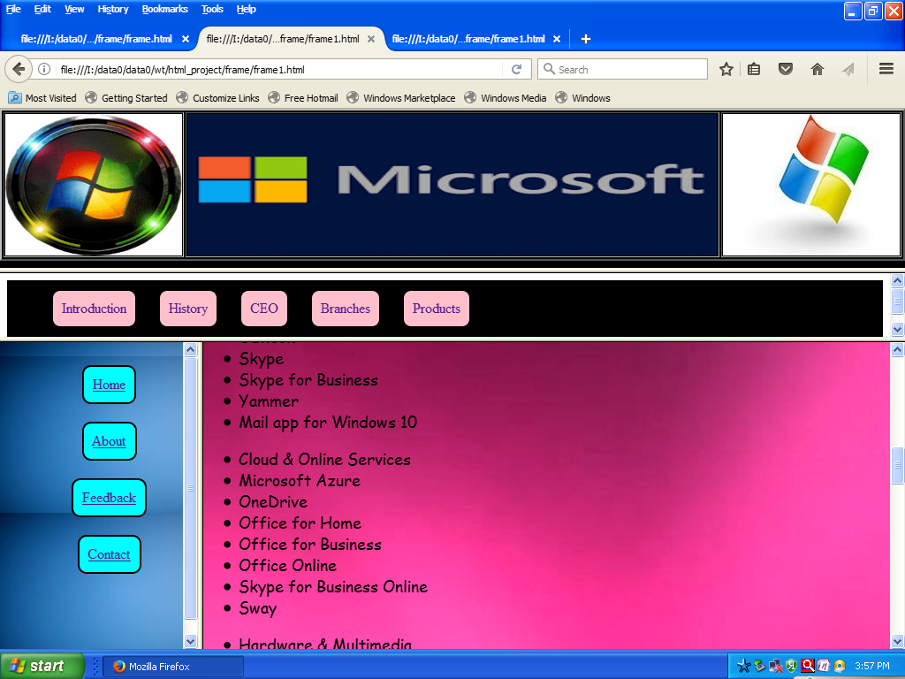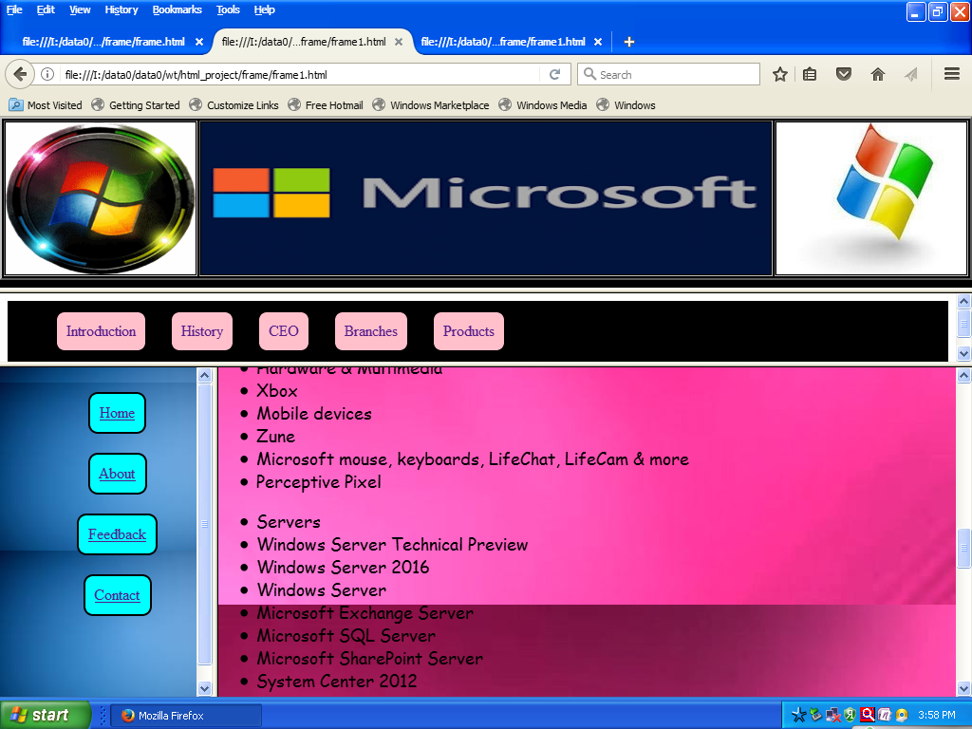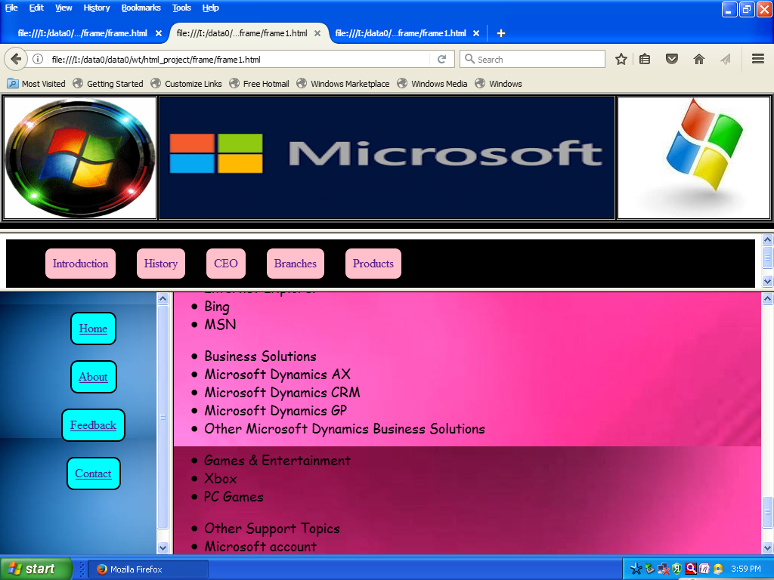

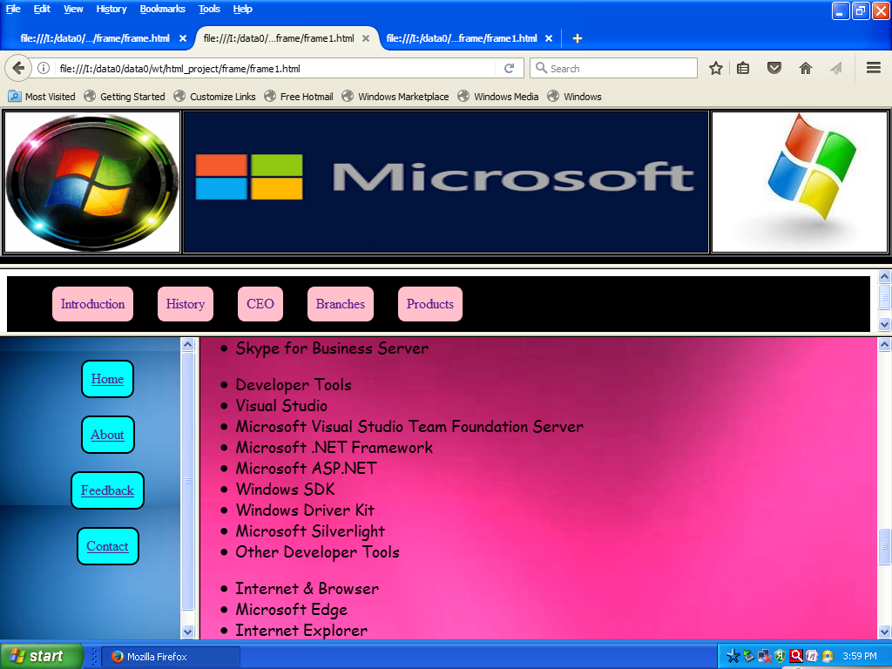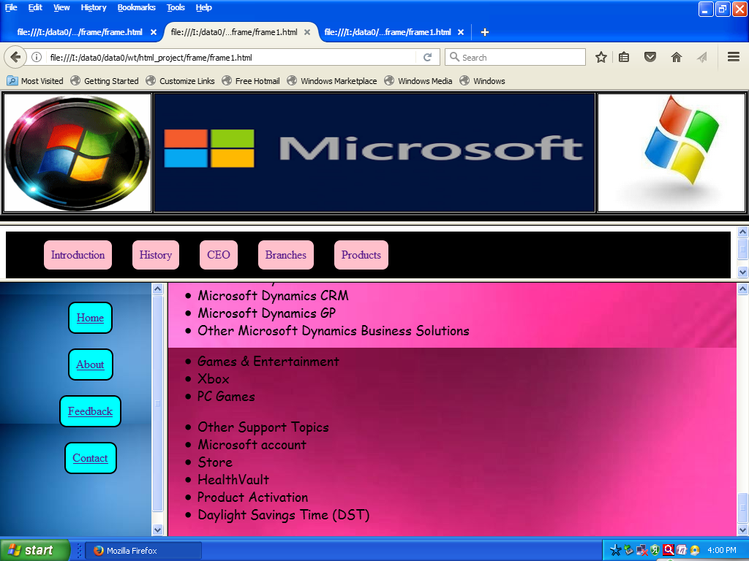

**Home page**

**List.html**

<html>

<head>

<title>display list</title>

<style>

tr

{

font-size:18px;

font-family:arial;

}

body,html

{

margin:0; padding:0; height:100%; width:100%;

background-image: url("list.bmp");

}

#bgimg

{

position:fixed; left:0; top:0; z-index:1; height:100%; width:100%;

}

#content

{

position:absolute; left:0; top:0; z-index:70; height:100%; width:100%;

}

</style>

</head>

<body bgcolor="tan">

<table border="2" align=center>

<tr>

<td> <img src="right.bmp" width="210px" height="160px"/></td>

<td> <h2><font face="times new roman" size="10" color="purple" align="center">

<b> <i><blink><h5>MULTINATIONAL COMPANIES</h5></i></b></blink></td>

<td> <img src="left.bmp" width="180px" height="160px"/></td>

</tr>

</table>

</body>

</html>

**Main.html**

<html>

<head>

<title>Displaying horizontal list</title>

<style>

ul li

{

display:inline-block;

background-color:aqua;

padding: 10px;

margin: 10px;

border-radius: 10px;

border:2px solid black;

}

ul li a:hover

{

background-color:yellow;

text decoration:none;

color:red;

margin:7px;

padding:7px

}

body,html

{

margin:0; padding:0; height:100%; width:100%;

background-image: url("37.jpg");

}

#bgimg

{

position:fixed; left:0; top:0; z-index:1; height:100%; width:100%;

}

#content

{

position:absolute; left:0; top:0; z-index:70; height:100%; width:100%;

}

</style>

</head>

<center>

<ul class="menu">

<li><a href="home.html" target="right">Home</a></li><br>

<li><a href="about.html" target="right">About</a></li><br>

<li><a href="feedback.html" target="right">Feedback</a></li><br>

<li><a href="Contact.html" target="right">Contact</a></li><br>

</ul>

<center>

</body>

</html>

**Home.html**

<html>

<body>

<head>

<style>

body,html

{

margin:0; padding:0; height:100%; width:100%;

background-image: url("home.bmp");

}

</style>

</head>

<body>

<table border="2" align="center">

<tr>

<td>

<a href="frame1.html" target="_blank"> <img src="ms.bmp" width="150" height="110"/></a>

</td>

<td>

<a href="frame2.html"target="_blank"><img src="ibm.bmp" width="150" height="110"/></a>

</td>

<td>

<a href="frame3.html"target="_blank"> <img src="nestle.bmp" width="150" height="110"/></a>

</td>

</tr>

<tr>

<td>

<a href="frame4.html"target="_blank"> <img src="png.bmp" width="150" height="110"/></a>

</td>

<td>

<a href="frame5.html"target="_blank"> <img src="pepsico_l.bmp" width="150" height="110"/></a>

</td>

<td>

<a href="frame6.html"target="_blank"> <img src="cocacloa.bmp" width="150" height="110"/></a>

</td>

</tr>

<tr>

<td>

<a href="frame7.html"target="_blank"> <img src="citi.bmp" width="150" height="110"/></a>

</td>

<td>

<a href="frame8.html"target="_blank"> <img src="hp.bmp" width="150" height="110"/></a>

</td>

<td>

<a href="frame9.html"target="_blank"> <img src="apple1.bmp" width="150" height="110"/></a>

</td>

</tr>

</table>

</body>

<html>

**Frame.html**

<html>

<frameset rows="30%, 60%,10%" >

<frame src="list.html" name="top" noresize scrolling="auto">

<frameset cols="22%,78%">

<frame src="main.html" name="left" >

<frame src="about.html" name="right">

</frameset>

<frame src="footer.html">

</frameset>

</html>

**Footer.html**

<html>

<head>

<title>

marquee </title>

</head>

<body bgcolor=pink>

<marquee> <h1><font_color="red">copyright &copy; 2017</font></h1></marquee>

</body>

</html>

**About Us**

<html>

<head><title>Apple introduction</TITLE>

<style>

body,html

{

margin:0; padding:0; height:100%; width:100%;

font-family:"Comic sans MS";

font-size:18px;

background-image: url("555.jpg");

}

</style>

</HEAD>

<body bgcolor= "white" text="black">

<h1 align="center">About Multinational Companies</h1>

In turn, India also derives a lot of benefits from MNCs such as higher level of investment, reduction in technological gap, optimum utilization of natural resources, reduction in foreign exchange gap and boost to basic economic structure. But roses do not come without thorns.

So there are certain disadvantages of having MNCs in a developing country like India like competition to SMSI, increased pollution and environmental hazards, improper diffusion of profits and Forex imbalance, slow decision making and sometimes economic distress. But these don’t overcome the gains of having MNCs.

With just a few days left for the announcement of the Union Budget 2016, a survey has found that the youth’s desire to work in startups has increased from 8% to 14%. While half of the respondents conveyed their intention to start their own company, a marginal ¾ students actually didn’t have any idea as to how to take the ideas forward. Therefore, a majority of students looking for stable job opportunities would want to work with an MNC or some SME.

In India, a large number of MNCs are operating. So, here we have compiled a list of a couple of major MNCs in India:

List of Top 9 MNCs<br><br>

Microsoft <br>

International Business Machines (IBM)<br>

Nokia Corporation<br>Nestle<br>

Procter and Gamble<br>

PepsiCo<br>

Coca Cola<br>Citigroup<br>Hawlett Packard<br>

Apple<br>

</body>

</html>

**Feedback Form**

<html>

<head>

<title> Feedback Form</title>

<style>

body,html

{

margin:0; padding:0; height:100%; width:100%;

background-image: url("19.jpg");

font-color:green;

}

#bgimg

{

position:fixed; left:0; top:0; z-index:1; height:100%; width:100%;

}

#content

{

position:absolute; left:0; top:0; z-index:70; height:100%; width:100%;

}

</style>

</head>

<center><h1><font color="White">Feedback Form</font><h1></center>

<form action=""method="">

<center>

<b>First name:-</b><input type="text"/><br><br>

<b>Last name:-</b><input type="text"/><br><br>

<b>Email&nbsp; &nbsp; &nbsp; &nbsp;:-<input type="text"/></br> <br>

age&nbsp;&nbsp;&nbsp;&nbsp;&nbsp;&nbsp;&nbsp;&nbsp;&nbsp;&nbsp;:-<select></br><br><b>

<option>18</option>

<option>19</option>

<option>20</option>

<option>21</option>

<option>22</option>

</select> <br><br>

DOB&nbsp;&nbsp;&nbsp;&nbsp;&nbsp;&nbsp;&nbsp;:-<select>

<option>DD</option>

<option>1

<option>2

<option>3

<option>4

</select>

<select>

<option>MM</option>

<option>1

<option>2

<option>3

<option>4

</select>

<select>

<option>YY</option>

<option>1985

<option>1986

<option>1987

<option>1988

<option>1989

<option>1990

</select></br> <br>

Gender &nbsp;&nbsp;&nbsp;:-

male<input type="radio"name="gender"/>

female<input type="radio"name="gender"/></br><br>

Did you like this:-<br>&nbsp;&nbsp;&nbsp;&nbsp;&nbsp;&nbsp;&nbsp;&nbsp;&nbsp;&nbsp;&nbsp;&nbsp;&nbsp;&nbsp;&nbsp;&nbsp;&nbsp;&nbsp;Yes<input type="radio"name="like"/>

No<input type="radio"name="like"/></br> <br>

<b>Comments:-</b><br>

&nbsp;&nbsp;&nbsp;&nbsp;&nbsp;&nbsp;&nbsp;&nbsp;&nbsp;&nbsp;&nbsp;&nbsp;&nbsp;&nbsp;&nbsp;&nbsp;&nbsp;&nbsp;&nbsp;

<textarea rows="1"cols="40" name="txtadress" ></textarea><br>

<br>

<input type="button"value="submit"></button></center>

</form>

</body>

</html

**Contact Us**

<html>

<head> <title> Contact us</title>

<style>

body,html

{

margin:0; padding:0; height:100%; width:100%;

background-image: url("222.jpg");

font-color:green;

}

#bgimg

{

position:fixed; left:0; top:0; z-index:1; height:100%; width:100%;

}

#content

{

position:absolute; left:0; top:0; z-index:70; height:100%; width:100%;

}

</style>

</head>

<center><h1><font color="White">Contact us</font></h1>

<iframe src="https://www.google.com/maps/embed?pb=!1m18!1m12!1m3!1d122189.87346957295!2d74.51405917346948!3d16.85443471570916!2m3!1f0!2f0!3f0!3m2!1i1024!2i768!4f13.1!3m3!1m2!1s0x3bc10c8187f060eb%3A0x37911f53cdc1ddb3!2sSangli%2C+Maharashtra!5e0!3m2!1sen!2sin!4v1488533269553" width="600" height="450" frameborder="0" style="border:0" allowfullscreen></iframe></center>

</body>

</html>

**1_Intro.html**

<html>

<head>

<title>MS_Introduction

</title>

<style>

body,html

{

margin:0; padding:0; height:100%; width:100%;

font-family:"Comic sans MS";

font-size:18px;

background-image: url("52.jpg");

}

</style>

</head>

<body>

<h2> INTRODUCTION</H2>

&nbsp;&nbsp;&nbsp;&nbsp;&nbsp;Microsoft India Private Limited is a subsidiary of American software company Microsoft Corporation, headquartered in Hyderabad, India. The company first entered the Indian market in 1990 and has since worked closely with the Indian government, the IT industry, academia and the local developer community to usher in some of the early successes in the IT market. Microsoft currently has offices in the 13 cities of Ahmedabad, Bangalore, Chandigarh, Chennai, Coimbatore, Hyderabad, Indore, Jaipur, Kochi, Kolkata, Mumbai, New Delhi, and Pune. Increasingly, the company has become a key IT partner of the Indian government and industry, supporting and fueling the growth of the local IT industry through its partner enablement programs.

<br><br> Since its entry into India, Microsoft has focused on three key objectives:

<ul>

<li>To become a key IT partner of the Indian government and the local IT industry</li>

<li>To support and fuel growth of the local IT industry through its partner enablement programs</li>

<li>To use the Microsoft Unlimited Potential program to enhance education, jobs and opportunities and foster innovation through relevant, affordable access to computing.</li>

</ul>

Microsoft in India employs about 6,500 people and has six business units representing the complete Microsoft product portfolio. Bhaskar Pramanik, Chairman of Microsoft India, announced that Microsoft intends to provide free internet connectivity across India.

Microsoft India increased maternity leave for their female employees in 1 February 2016 from 3 months to 6 months (if the child was born from the woman), and for mothers of adopted children to eight calendar weeks.

</body>

</html>

**User Mannual**

**5. USER MANUAL**

This Website is very useful to get All the Information and Procedures about various **Multinational Companies …….**

The description of each Main Page and its Sub-Page are as follows:-

1. **HOME:-**

This page contains various main menus in the form of table.

**1.Microsoft**

**1.1 Introduction:-**

Contains introduction of Microsoft.

* 1. **History:-**

Contains history of Microsoft.

* 1. **CEO:-**

Contains information of CEO of Microsoft.

**1.4 Branches:-**

Contains various branches of Microsoft.

**1.5 Products:-**

Contains information of overall products of Microsoft.

1. **IBM**

**2.1 Introduction:-**

Contains introduction of IBM.

**2.2 History:-**

Contains history of IBM.

**2.3 Products and services:-**

Contains Products and services of IBM.

**2.4 Brands and Reputations:-**

Contains various Brands and Reputations of IBM.

**2.5 Research:-**

Contains information related research of IBM.

**2.6 People and Culture:-**

Contains information of People and Culture of IBM.

**2.7 Shares:-**

Contains information share investment of IBM.

1. **Nestle**

**3.1 Introduction:-**

Contains introduction of Nestle.

**3.2 History:-**

Contains history of Nestle.

**3.3 Brands :-**

Contains various Brands of Nestle.

1. **P&G**

**4.1 Introduction:-**

Contains introduction of P&G.

**4.2 History:-**

Contains history of P&G.

**4.3 CEO:-**

Contains information of CEO of P&G.

**4.4 Products:-**

Contains information of various products of P&G.

1. **PepsiCo**

**5.1 History:-**

Contains history of PepsiCO.

* 1. **CEO:-**

Contains information of CEO of PepsiCO.

**5.3 Products:-**

Contains information of various products of PepsiCO.

1. **Coca-Cola**

**6.1 Introduction:-**

Contains introduction of Coca-Cola.

**6.2 History:-**

Contains history of Coca-Cola.

**6.3 CEO:-**

Contains information of CEO of Coca-Cola.

**6.4 Products:-**

Contains information of various products of Coca-Cola.

1. **CITI Group**

**7.1 Introduction:-**

Contains introduction of CITI group.

**7.2 History:-**

Contains history of CITI group.

**7.3 CEO:-**

Contains information of CEO of CITI group.

1. **HP**

**8.1 Introduction:-**

Contains introduction of HP.

**8.2 History:-**

Contains history of HP.

**8.3 CEO:-**

Contains information of CEO of HP.

1. **Apple**

**9.1 Introduction:-**

Contains introduction of Apple.

**9.2 History:-**

Contains history of Apple.

**9.3 CEO:-**

Contains information of CEO of Apple.

**9.4 Products:-**

Contains information of various products of Apple.

**Conclusion**

**6. CONCLUCION**

In the development of this project we have learn the importance of html with internet related activities the internet as we know is new communication technology that is affecting our lives on scale as significant as the television or the telephone if we want to use telephone write letters, read newspapers, magazines, do business or any kind of research the internet can radically alter our entire view. The internet & online services are growing very rapidly as consumers and organizations seek access to broad range of information & services.

Today, in the world of digital technology it is must for each of us to be in touch with the internet which we would change our lives in one way or the other. Internet can do wonder to resolve the problem using the internet we can communicate with the world. Display ourselves, & obtained the required inflation regardless of time & place.

Surfing the internet, one has access to various sites or locations having details about a particular organization, company, products or even individual. These organizations or individuals have attractive web pages for the user logged on to that site.

One of the best advantages of website development is that, it provides online detail information at any time through all over the world. Due to this advantage, any one can access information related to subject. Due to this facility I have decided to develop website & for this I have selected subject of **“Multinational Companies”.**

**Bibliography**

**7. BIBLIOGRAPHY**

1. HTML Black Book

- Steven Holzner.

1. Information Technology

- Nirali Publications.

1. HTML, DHTML, JAVA script, CGL

- Ivan Bayross.